CHAPTER ONE

INTRODUCTION

1.1 Background to the Study
Land is the foundational asset on which economic security, social stability and human development rest, and the institutions that record rights to it are therefore among the most consequential in any society. Where tenure is secure, individuals invest, access credit and resolve disputes with confidence, and the wider economy benefits from higher agricultural investment, reduced conflict and stronger public trust (Byamugisha & Dubosse, 2023; Rodima-Taylor, 2021). The administration of land is thus not a clerical function but a determinant of national prosperity, and its failure imposes costs that radiate across the economy and the social order.
Despite this importance, land administration remains insecure across much of the world. Conventional, paper-based registries are susceptible to physical deterioration, deliberate alteration and discretionary manipulation, while partially digitised systems frequently reproduce the same weaknesses by digitising fragmented records without securing them against tampering (Ansah et al., 2023; Mintah et al., 2021). The result is a global governance deficit in which the institution charged with protecting land rights is itself a site of vulnerability.
Against this backdrop, distributed-ledger technology has emerged worldwide as a candidate infrastructure for securing land records. A blockchain is a decentralised, cryptographically secured and append-only ledger whose validated entries are computationally infeasible to alter, yielding immutability, transparency and verifiability without reliance on a single trusted authority (Casino et al., 2019; Kshetri, 2021). These properties map closely onto the requirements of a trustworthy land registry, and the technology has consequently attracted intense scholarly and governmental interest as a means of producing tamper-proof, auditable records (Ameyaw & De Vries, 2021).
The global evidence, however, indicates that the promise remains largely unrealised, which is precisely what keeps the problem current rather than settled. National pilots in countries such as Georgia, Sweden and Ghana demonstrated technical feasibility but produced mixed and frequently limited outcomes, with several initiatives stalling at a proof-of-concept stage rather than achieving decentralised, nationwide operation (Shang & Price, 2019; Konashevych, 2020; Ansah et al., 2023). This persistent gap between blockchain’s theoretical promise and its practical delivery frames the present study, which now narrows from the global condition to the setting in which these challenges are most acute.
The legal foundation of Nigerian land administration is the Land Use Act of 1978, which vested all land in each state in the Governor, to be held in trust and administered for the use and common benefit of all citizens. While the Act sought to unify a fragmented tenure landscape, its implementation has been marked by bureaucratic delay, costly and opaque titling, and the persistence of customary claims that the statutory system imperfectly accommodates (Land Use Act, 1978; Mintah et al., 2021). The coexistence of statutory and customary tenure produces a dual system in which the same parcel may be claimed under different legitimating logics, a condition that titling alone has proven unable to resolve.
Taken together, these limitations define a clear and significant research gap: there exists no empirically validated, multi-technology framework that simultaneously integrates GIS-based spatial integrity, NFT-based title tokenisation, MQTT-enabled offline support and hybrid social oracles for community validation, with explicit alignment to Nigeria’s legal context. Therefore, this study sets out to design, develop and evaluate such a framework, using Nigeria as a representative Global-South, dual-tenure, low-connectivity validation setting, in order to advance land administration from isolated, technically-focused proofs of concept toward an integrated, inclusive and tamper-proof architecture. This aim leads directly into the statement of the problem and the research questions that follow.

1.2 Statement of the Problem
Conventional and partially digitised land administration systems fail to protect land records against manipulation, to operate under the connectivity constraints of rural areas, and to incorporate the community validation needed to reconcile statutory and customary tenure. These failures sustain corruption, multiple allocation, revenue loss and the exclusion of vulnerable right-holders, and they are especially severe in Nigeria, where discretionary administrative power under the Land Use Act (1978) compounds technological weakness (Ansah et al., 2023; Mintah et al., 2021).
Although blockchain technology is widely proposed as a remedy, existing solutions address the problem only in part. They advance single technologies secure storage, or spatial mapping, or tokenisation, or oracle-based validation without integrating them, and they remain largely conceptual rather than empirically validated (Konashevych, 2020; Saari et al., 2022; Faku & Amadi-Echendu, 2026). Critically, no existing framework combines GIS, NFTs, MQTT-enabled offline support and hybrid social oracles within a single, legally-aligned architecture, and none has been evaluated for its capacity to improve data security, reduce fraud and increase transparency relative to conventional registries.
This gap limits the development of practical, scalable, tamper-proof solutions for anti-corruption and inclusive land governance. The problem this study addresses is therefore the absence of an integrated, empirically validated, legally-aligned land administration framework capable of delivering tamper-proof and inclusive governance under the dual-tenure, low-connectivity conditions that characterise Nigeria and comparable Global-South jurisdictions.

1.3 Aim and Objectives of the Study
The aim of this study is to design, develop and empirically evaluate an integrated, tamper-proof land administration framework that converges Geographic Information Systems, non-fungible token blockchain technology, MQTT-enabled offline support and hybrid social oracles, with explicit alignment to Nigeria’s legal context. The specific objectives are to:
- design an integrated architecture that combines GIS-based spatial integrity, NFT-based title tokenisation, MQTT-enabled offline data capture and synchronisation, and hybrid social oracles for community validation;
- implement a prototype instantiation of the framework in explicit alignment with the provisions of the Land Use Act (1978);
- evaluate the framework’s performance in terms of data security, fraud reduction and network performance

CHAPTER THREE

METHODOLOGY

3.1 Introduction
This chapter sets out how the study was conducted. It begins by stating the research philosophy and design, justifying the choice of Design Science Research as the paradigm capable of both constructing and rigorously evaluating the integrated artefact the field lacks. It then operationalises that paradigm through the Design-by-Objective framework, devoting a subsection to each of the study’s five objectives and reporting, for each, the specific objective addressed, the action taken to address it, and the outcome produced. The DSR process maps directly onto the study’s objectives, so that the methodology is structured by objective rather than by generic research stage. This mapping is summarised in Table 3.1 and elaborated, objective by objective, in the section that follows.
Table 3.1 Design-by-Objective mapping of objectives, research questions, DSR activities, methods and deliverables
Table 3. 1 Design-by-Objective mapping of objectives, DSR activities
Objective | DSR activity | Principal method | Deliverable
1 | Problem & objectives | Documentary analysis of the Land Use Act (1978); thematic requirements synthesis | Requirements specification
2 | Design | Layered architecture design (GIS oracle, hybrid-consensus ledger, ERC-721, social oracle, MQTT) | Reference architecture
3 | Development & demonstration | Prototype on Hyperledger Besu; Solidity, Node.js, geospatial stack, MQTT | Working prototype
4 | Evaluation | FEDS evaluation; security, fraud, transparency, performance vs baseline | Evaluation results

3.3 System Design and Modeling
System architecture uses Principles of Object-Oriented Programming and Unified Modeling language to organize the framework into modular and reusable modules based on the layered architecture principles of separating blockchain consensus layers, GIS spatial validation layers, NFT token management layers, and application interface layers.

3.6.1 Use Case Diagram
Figure 3.2 illustrates the functional interactions between the major stakeholders and the proposed blockchain-based land administration system. The diagram identifies key actors, including the Land Administrator, Surveyor, Community Representative, Legal Officer, Registrar, and Citizen, together with the core system functions such as land registration, spatial verification, customary claim validation, NFT title issuance, ownership transfer, dispute management, and reporting. It also shows the integration of external services, including the blockchain ledger, GIS spatial database, smart contracts, and MQTT offline synchronization, demonstrating how users interact with the system to achieve secure, transparent, and efficient land administration.
.

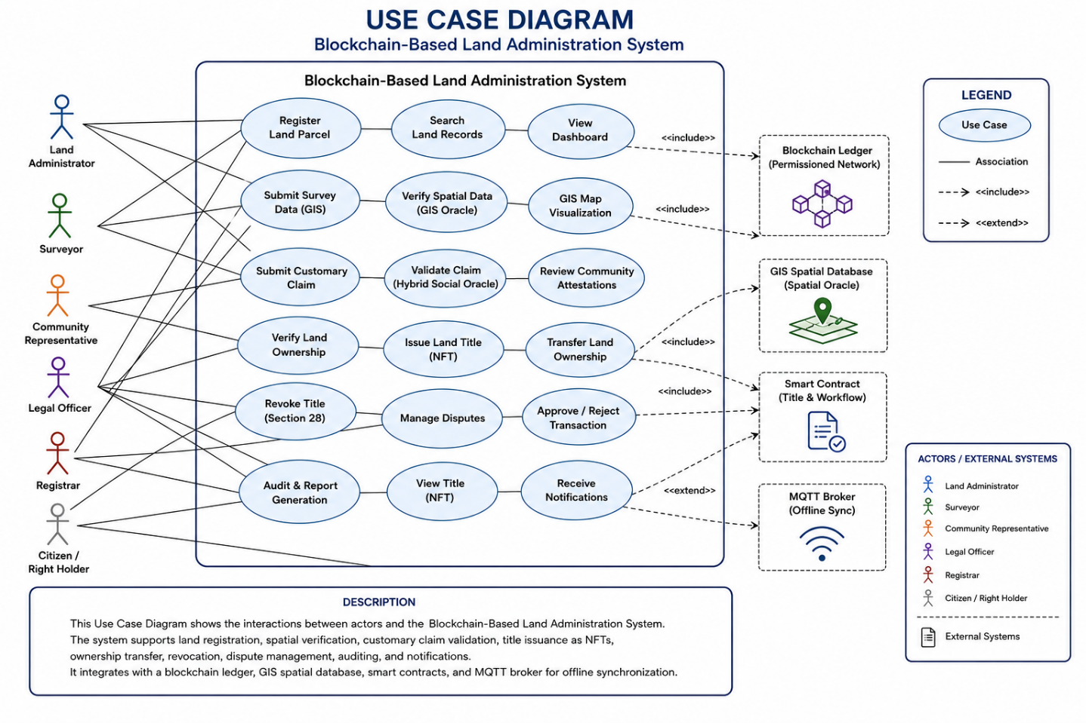
Figure 3. 2: Use Case Diagram

3.6.2 Activity Diagram: Land Registration Workflow
The Activity diagram represents the workflow of first application to NFT minting automatically encompassing the resilient-by-design offline feature. The workflow reflects the way applications launched in low connectivity environments are cached on-premise before synchronization, the way spatial data is processed through GIS Oracle validation before coordinate accuracy, the way customary parcels are verified by using Social Oracle multi-signature validation before proceeding and how all verified data are resolved on final blockchain before NFT generation and wallet transfer.

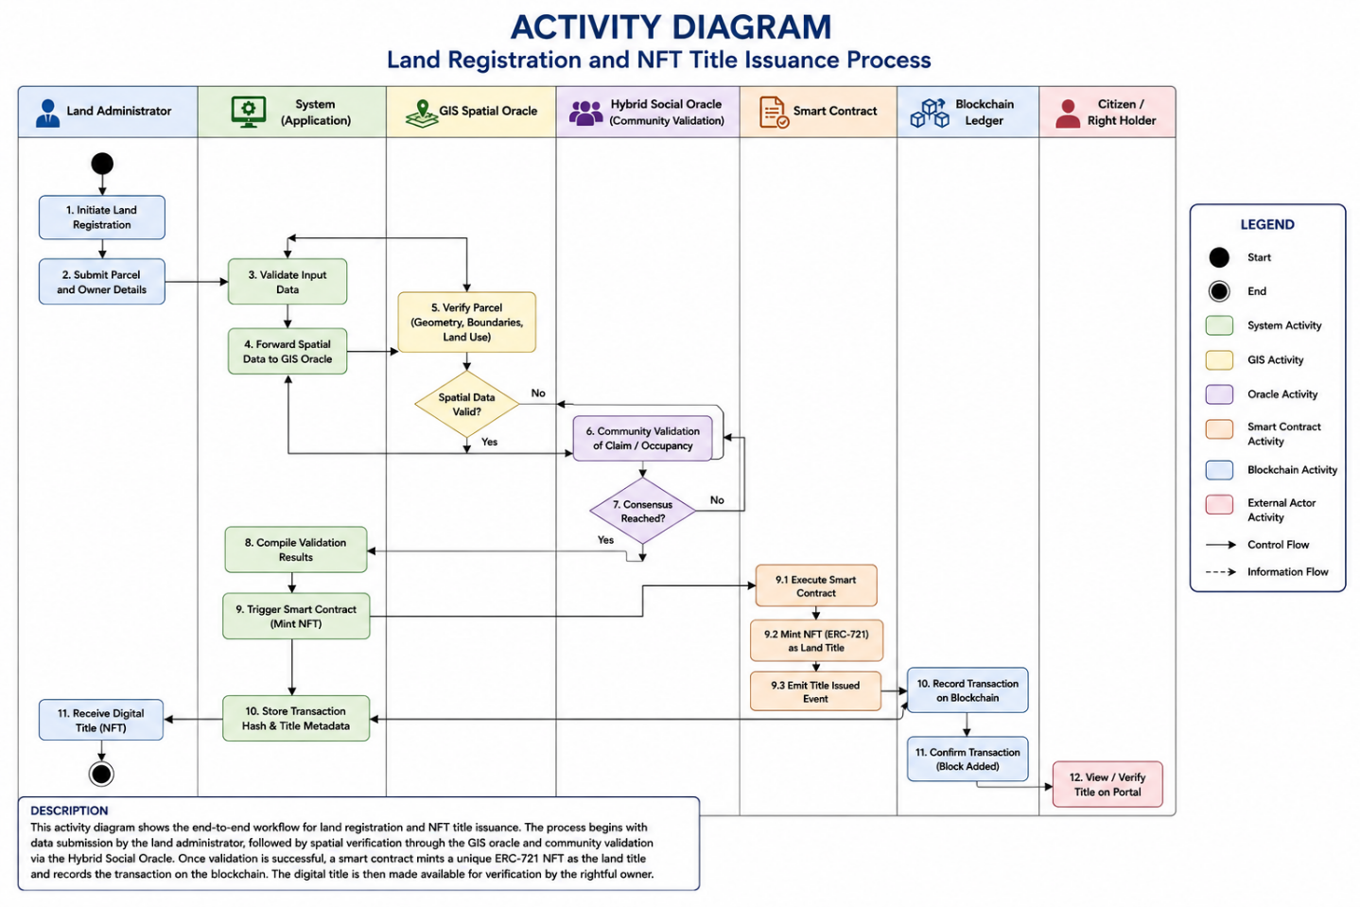
Figure 3. 3 Activity Diagram
Figure 3.3 illustrates the workflow for land registration and digital title issuance in the proposed system. The process begins with land registration and spatial verification using the GIS Spatial Oracle, followed by community validation through the Hybrid Social Oracle. Once the required validations are completed, a smart contract mints the land title as an ERC-721 NFT and records the transaction on the blockchain ledger. Finally, the digital title is issued to the rightful owner, ensuring a secure, transparent, and tamper-proof land registration process.

3.6.3 State Diagram: Land Parcel Lifecycle
State diagrams track state transitions of the land parcels in the system lifetime. The statuses of parcels start as Unregistered, move to Pending when the application is submitted, and become Validated after a successful verification with GIS and Social Oracle, are Minted when the NFT is generated and recorded on blockchain, may be moved to the Transferred state when the governance is transferred to different owners, and may be moved to the Revoked state when the governors assert authority by using Section 28 via hierarchical governance protocols. The transition between the states provokes particular events of smart contracts that are immutable and stored in audit trails.
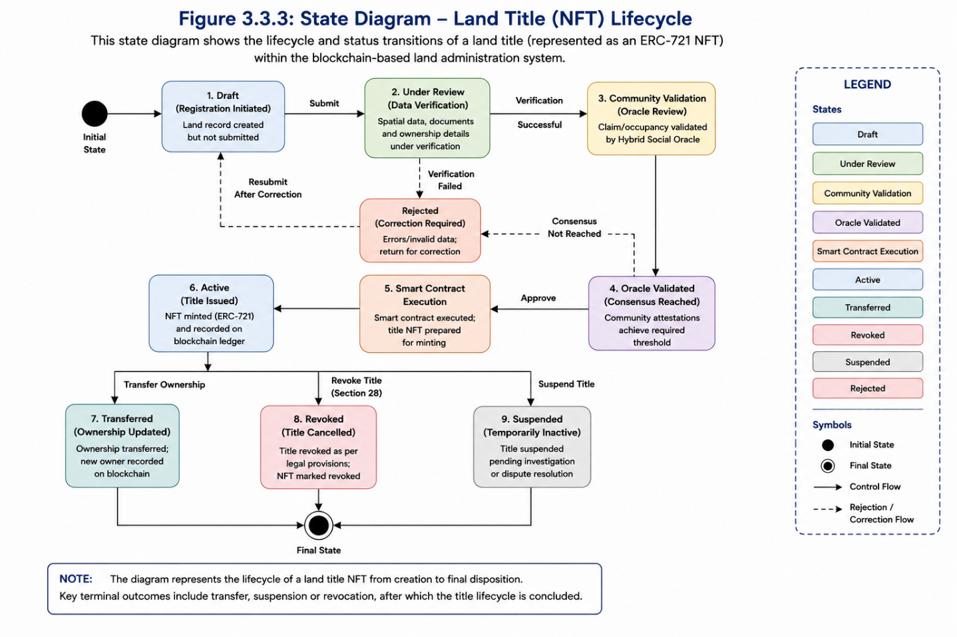
Figure 3. 4: State Diagram - Land Parcel Lifecycle Management

Figure 3.4 illustrates the lifecycle of a digital land title within the proposed blockchain-based land administration system. The diagram shows how a land title progresses through key states, beginning with registration and verification, followed by community validation and smart contract execution before becoming an active NFT title on the blockchain. It also shows possible state transitions such as ownership transfer, suspension, revocation, or rejection, ensuring that every change in the title status is securely managed, traceable, and compliant with the land administration process.

3.6.4 Sequence Diagram: Registration and Transfer Interactions
This diagram maps temporal sequences of system component interactions in registration, and transfer of ownership processes. The flow shows the way Property Owners make applications via frontend interfaces, the way applications cause GIS Oracle coordinate verification queries, the way verified spatial data is sent to smart contract validation logic, the typical use of customary parcels by the Social Oracle multi-signature requirement, the way successful validation produces NFT minting functions, and the way the minted tokens are transferred to owner wallet addresses with a record of a blockchain transaction.
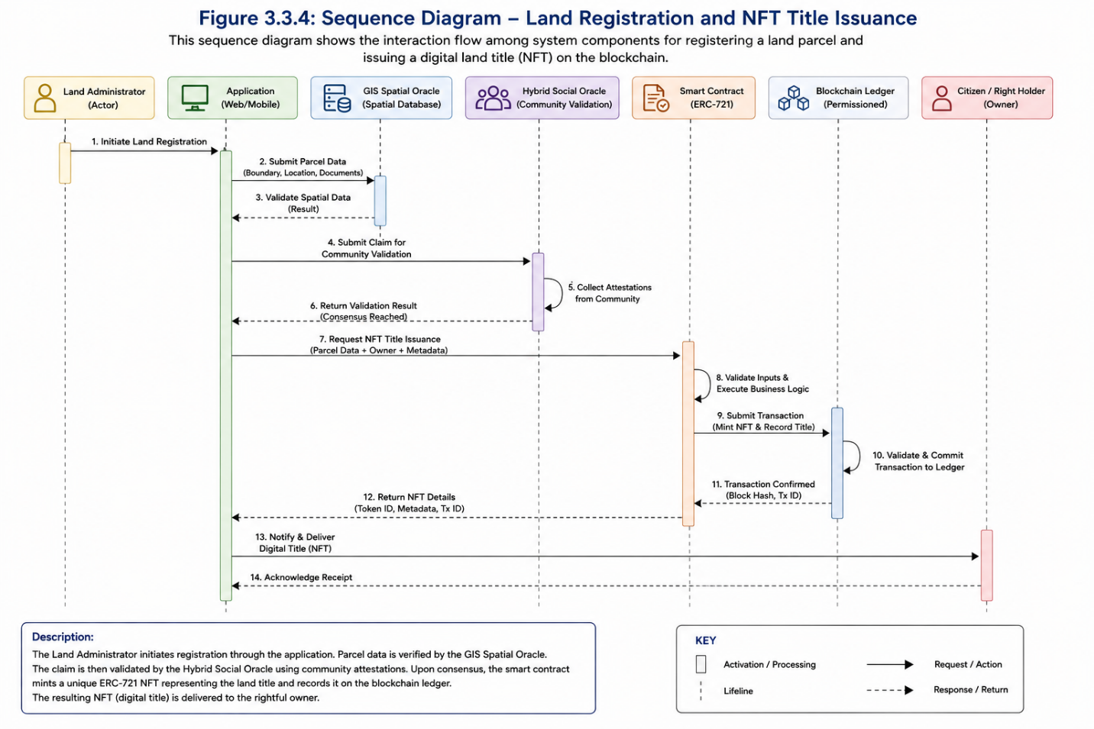
Figure 3. 5 Sequence Diagram - Land Registration and Ownership Transfer
Figure 3.5 illustrates the sequence of interactions among the system components during land registration and digital title issuance. The process begins when the Land Administrator submits land details through the application, followed by spatial verification using the GIS Spatial Oracle and community validation through the Hybrid Social Oracle. After successful validation, a smart contract mints the land title as an ERC-721 NFT, records the transaction on the blockchain ledger, and returns the digital title to the rightful owner, ensuring a secure, transparent, and traceable registration process.

3.6.5 Class Diagram: Structural Data Architecture
The Class diagram determines structural relationships between the entities of the system. The Figure 3.7 defines the structural relationships between system entities, and the figure shows the way the framework imposes data integrity. The LandParcel classes are required to have vital dependencies on the GISData class to verify spatial data and the NFTToken class to represent digitally.

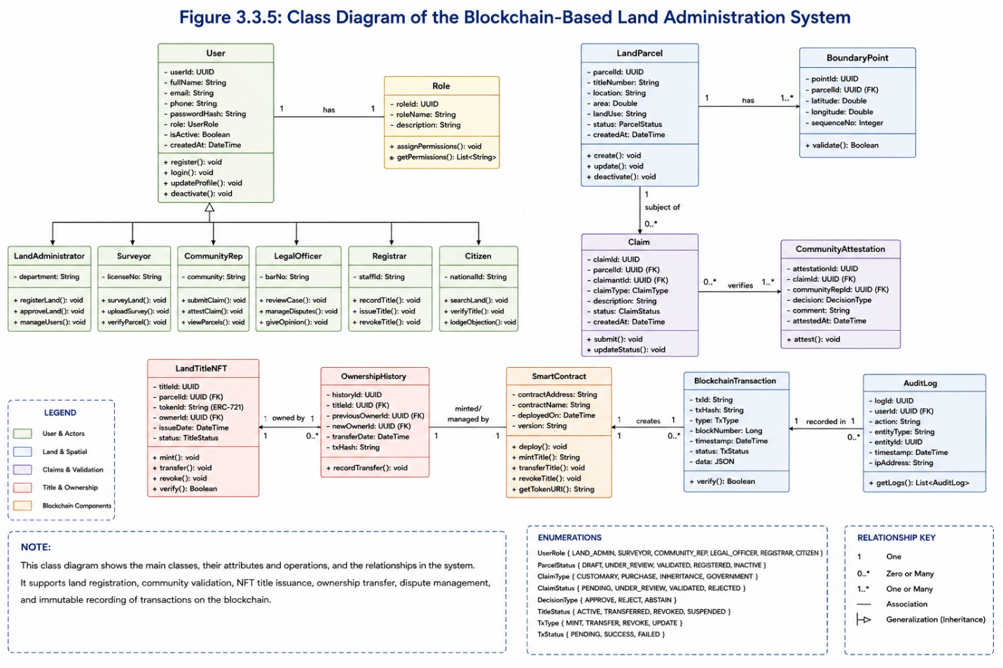
Figure 3. 6 Class Diagram - System Entity Relationships
Figure 3.6 presents the static structure of the proposed blockchain-based land administration system. It illustrates the major system classes, including users, land parcels, claims, land title NFTs, smart contracts, blockchain transactions, and audit logs, together with their attributes, operations, and relationships. The diagram demonstrates how these classes interact to support land registration, ownership verification, community validation, NFT title issuance, ownership transfer, and secure transaction recording on the blockchain.

3.6.6 Deployment Diagram
The deployment diagram refers to physical system configuration that is distributed through the infrastructure. Frontend servers that give the user interfaces are communicated with client applications (web browsers, mobile apps). Business logic is run on Backend application servers that interact with blockchain nodes that maintain distributed ledgers by Proof-of-Authority consensus. GIS servers take care of PostGIS spatial databases and offer Oracle validation services. The cadastral documentation and plans of survey on the IPFS nodes are stored in highresolution content-addressed distributed storage. This infrastructure design clearly resolves the infrastructure resilience requirements with the help of redundancy of nodes distribution and client design that is capable of going offline.

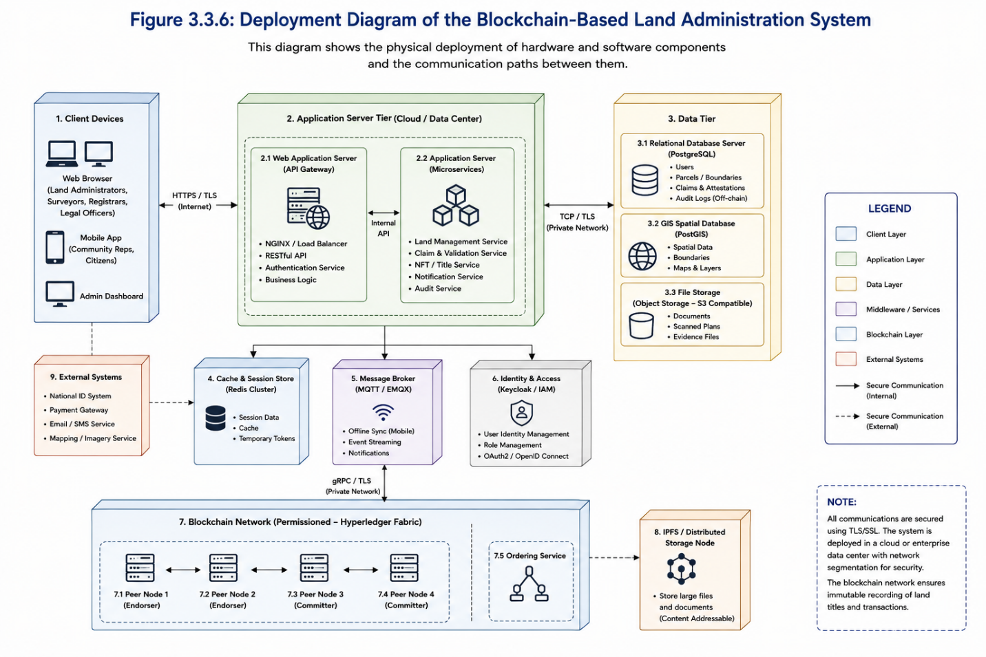
Figure 3. 7: Deployment Diagram - Physical System Configuration
Figure 3.3.6 illustrates the physical deployment of the proposed blockchain-based land administration system. It shows how client devices communicate securely with the application server, which interacts with the blockchain network, databases, GIS services, MQTT broker, and external government systems. The deployment architecture ensures secure communication, high availability, scalability, and reliable storage of land records across distributed system components.

3.7 System Logic and Procedural Flowcharts
Although the above UML diagrams establish the fixed structure and communication channels of the framework, during this section, the details of the dynamic operational reasoning will be provided. It shall show how the process of decision making will proceed step by step as it will govern the lifecycle of the title of the spatial-smart as it would guarantee that the statutory requirements will be executed using mathematical procedures instead of manual discretion.

3.7.1 Procedural Flowchart for Land Title Registration
The operational logic of new registrations will be embodied in the figure 3.8. This flow chart will trace the transaction pathway of starting the transaction up to the final commitment into a ledger. In contrast to the traditional registries, the flow will be checked by two crucial automated checks, which will be the Spatial Validation Gate (controlled by the GIS Oracle) and the Social Attestation Gate (controlled by the Multi-Signature protocol). In case a transaction fails the spatial intersection verification i.e. the coordinates overlap with an existing title, then the process will be automatically stopped by the smart contract without the formation of conflicting claims.
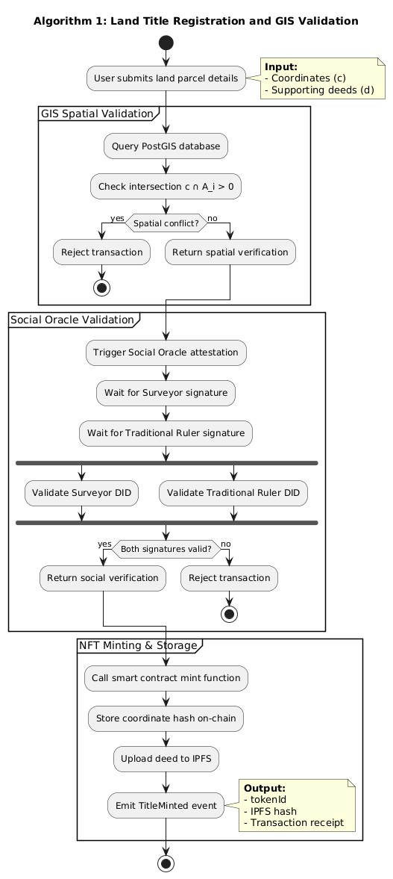
Figure 3.9: Procedural Flowchart for Land Title Registration and Validation

3.7.2 The Erdos Consensus and Governance Logic
The integrity of the framework will be based on the Erdos Consensus Algorithm that will be used to determine how the validator nodes will come to an agreement on the state of the ledger. The logic will be based on a state-transition model that will be customized to the type of transaction as will be shown in Figure 3.9. Normal land transfers will be processed through a Standard Consensus Path, but administrative procedures such as Gubernatorial Revocations in Section 28 of the Land Use Act will be processed through a Super-Majority Path. Such a path will need a super-majority (>75%) and it will enforce a cryptographic signature by a Judiciary Node, making it hard to make decisions of high-stake without institutional checks and balances.

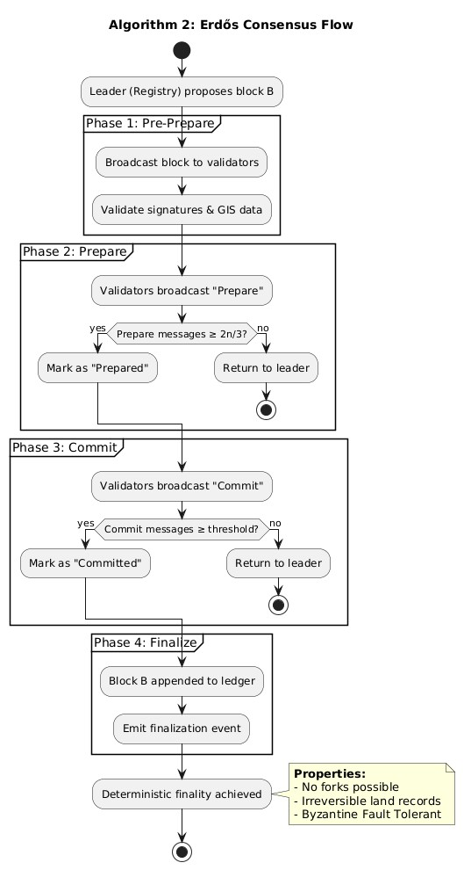
Figure 3.10: State Transition Logic of the Erdos Consensus Engine

3.7.3 Multi-layered Revocation Process
This flowchart will outline the administrative revocation procedure path of Land Use Act. It will highlight the Check-and-Balance loop whereby a request by a Governor will be put in a pending state until the Judiciary Node passes a cryptographic signature. This will make sure that the revocation satisfies statutory public interest criteria prior to the NFT metadata being changed to a Revoked state on the blockchain.
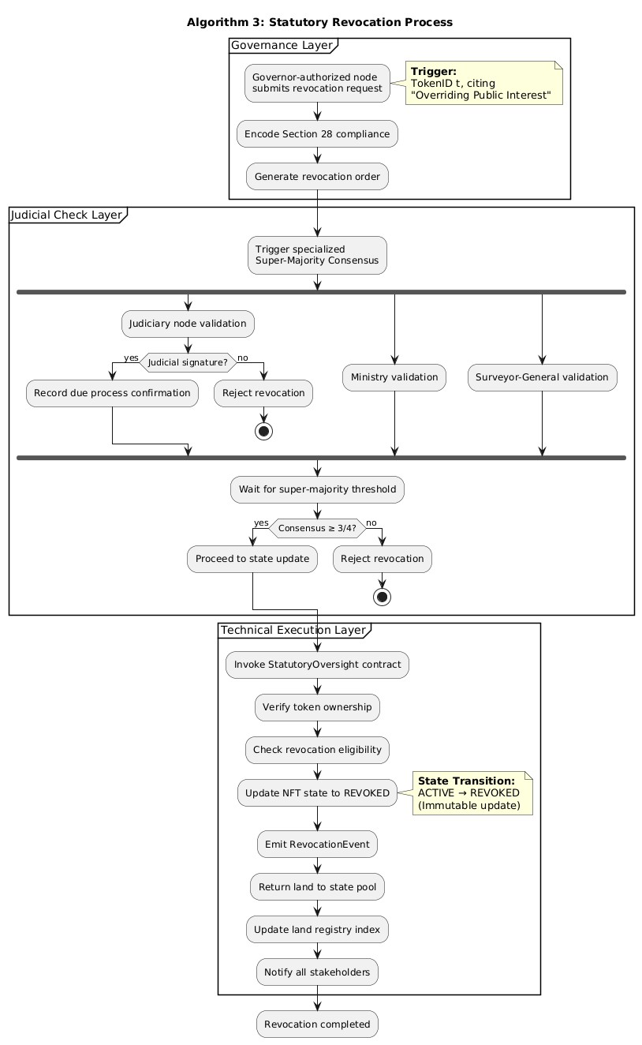
Figure 3. 11: Multi-layered Revocation Process with Judicial Oversight

3.7.4 Integrated System Interaction
The integrated system flowchart will offer a bird-eye perspective of the interaction of these independent processes in the entire ecosystem. It will demonstrate how one single registration request will initiate the GIS validation, and pass the data to the Erdos Consensus engine to finalizing the blocks, and be governed by the governance and revocation mechanisms of the state in general. This integration will make sure the physical land information and the online register are in balance.
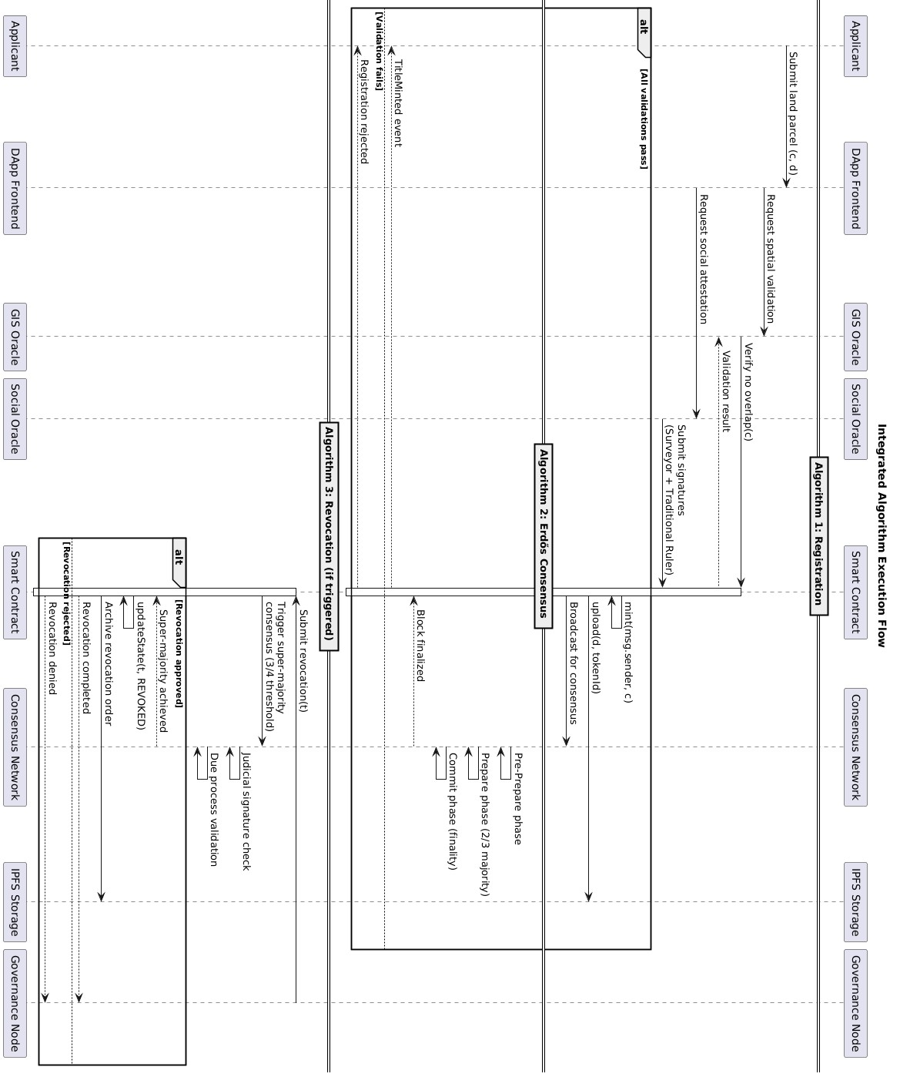
Figure 3.12: Integrated System Flow
3.8

3.2.4 Architectural Design
This subsection addresses Objective Two: to design an integrated architecture combining GIS-based spatial integrity, NFT-based title tokenisation, MQTT-enabled offline support and hybrid social oracles for community validation. It plugs the central gap identified throughout the study the absence of a single architecture that unifies these four strands.
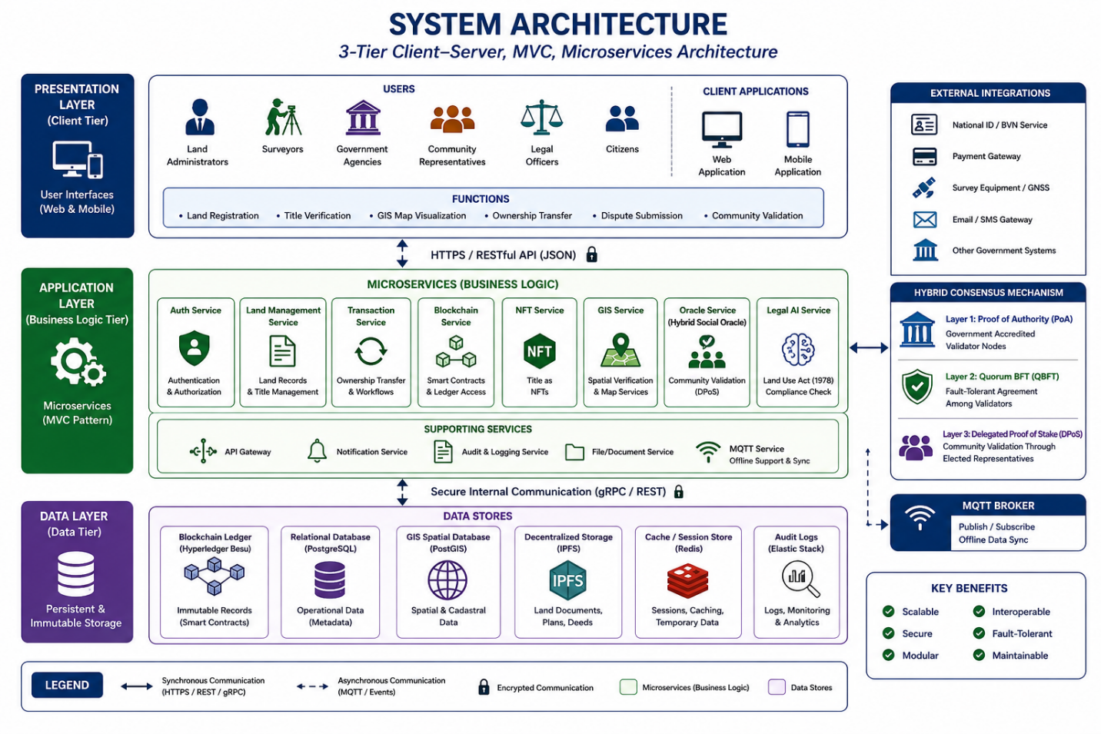
Figure 3. 8 Layered System Architecture
Figure 3.2 presents the layered architecture of the proposed blockchain-based land administration framework. The architecture is organised into five functional layers, each addressing a specific system requirement. The GIS Spatial Layer verifies cadastral and spatial data before land records are processed. The Blockchain Layer provides a secure and tamper-resistant distributed ledger for storing validated transactions. The Smart Contract and NFT Layer automates statutory land administration processes and issues each land title as a unique ERC-721 NFT. The Hybrid Social Oracle Layer combines institutional validation with community-based verification to authenticate customary land ownership claims. Finally, the MQTT Connectivity Layer enables offline data collection and secure synchronization when network connectivity is restored. Together, these interconnected layers provide a secure, transparent, legally compliant, and inclusive architecture for digital land administration while clearly defining the responsibilities and interactions of each system component.

3.4 The Hybrid Consensus Architecture
This subsection addresses Objective Two: to design an integrated architecture combining GIS-based spatial integrity, NFT-based title tokenisation, MQTT-enabled offline support and hybrid social oracles for community validation. A layered reference architecture was designed against the requirements specification, with each layer selected to satisfy a defined requirement. 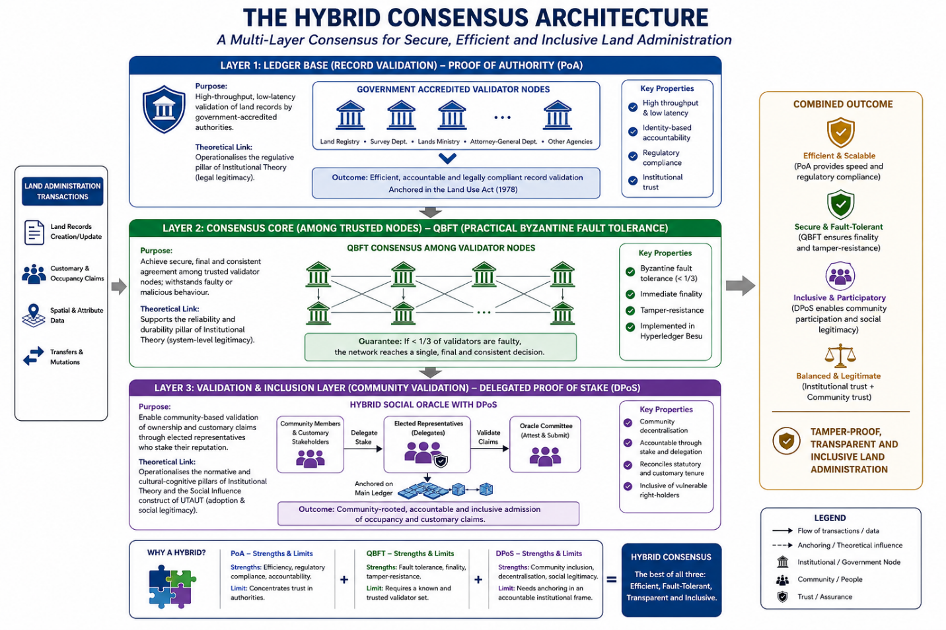
Figure 3. 9: Hybrid Consensus Architecture for Secure, Transparent, and Inclusive Land Administration
Figure 3.3 presents the hybrid consensus architecture that underpins the blockchain-enabled land administration framework. Rather than relying on a single consensus mechanism, the architecture integrates three complementary mechanisms to balance efficiency, security, regulatory compliance, and community participation. At the ledger layer, Proof of Authority (PoA) enables government-accredited validator nodes to validate and record land transactions efficiently while maintaining compliance with statutory regulations. The consensus layer employs Quorum Byzantine Fault Tolerance (QBFT) to ensure that all trusted validator nodes reach a single, tamper-resistant, and final agreement on every transaction, thereby strengthening the security and integrity of the blockchain. At the community validation layer, Delegated Proof of Stake (DPoS) supports the Hybrid Social Oracle by allowing elected community representatives to validate customary land ownership claims, ensuring inclusiveness and recognition of customary tenure. By combining these three mechanisms, the architecture provides a balanced consensus model that delivers secure, fault-tolerant, transparent, and inclusive land governance while addressing both institutional and community requirements.
Combined across the ledger and oracle layers, they yield a consensus design that is at once efficient, fault-tolerant, transparent and inclusive, balancing institutional trust with community participation in a manner that a single-mechanism ledger cannot achieve.
Table 3. 2 Roles of the three consensus mechanisms within the hybrid architecture
Mechanism | Architectural layer | Primary role | Property contributed | Trade-off it offsets
Proof of Authority (PoA) | Base ledger (government validators) | Government-controlled validation of land records | Efficiency, low latency and regulatory compliance | Anchors the system in accountable institutional authority
Quorum Byzantine Fault Tolerance (QBFT) | Base ledger (validator agreement) | Secure, final agreement among trusted validator nodes | Byzantine fault tolerance (up to one-third) and immediate finality | Offsets the single-authority fragility of PoA
Delegated Proof of Stake (DPoS) | Hybrid Social Oracle (validation layer) | Community-based validation of land-ownership claims | Decentralisation, inclusion and customary legitimacy | Offsets the trust concentration of PoA and QBFT

Computational Logic
The computational framework follows a deterministic execution pipeline in which each processing stage depends on the successful completion of the preceding stage. Land records first undergo spatial verification using the GIS module to eliminate duplicate or conflicting parcel boundaries. Successfully verified records proceed to community validation through the Hybrid Social Oracle, where customary ownership claims are evaluated against a predefined consensus threshold. The validated transaction is subsequently processed by the hybrid blockchain consensus mechanism comprising Proof of Authority (PoA), Quorum Byzantine Fault Tolerance (QBFT), and Delegated Proof of Stake (DPoS). Once consensus is achieved, the smart contract automatically validates statutory conditions, mints an ERC-721 NFT representing the land title, records the immutable transaction on the blockchain ledger, and updates the ownership registry. This sequential computational logic ensures that every land transaction satisfies spatial, social, institutional, and legal requirements before permanent blockchain registration, thereby providing a secure, transparent, tamper-resistant, and computationally efficient land administration framework.

3.5 Technology Stack and Tools
The permissioned, EVM-compatible ledger accommodates both the proposed reputation-weighted consensus and the standardised token model; the open geospatial stack secures spatial integrity without proprietary lock-in; the lightweight messaging protocol extends the system to constrained networks; and the application layer orchestrates the oracles and synchronisation services. The principal elements are summarised in Table 3.3.
Table 3. 3 Technology stack and the function of each element within the framework
Architectural layer | Technology / standard | Function in the framework
Ledger / consensus | Hyperledger Besu; hybrid PoA + QBFT + DPoS consensus | Permissioned, EVM-compatible tamper-resistant substrate with multi-layer consensus: authority, Byzantine fault tolerance and delegated stake
Tokenisation / contracts | Solidity; ERC-721 | Unique title tokens and encoded statutory workflow, including Section 28 logic
Spatial integrity | Open geospatial stack; GIS Spatial Oracle | Verification and admission of cadastral geometry; binds title to parcel
Community validation | Hybrid Social Oracle | Admits community- and human-validated occupancy and customary claims
Connectivity | MQTT publish–subscribe protocol | Offline data capture and secure later synchronisation
Application / orchestration | Node.js application layer | Coordinates oracles, synchronisation and contract interactions

3.6 Evaluation Framework and Metrics
This subsection addresses Objective Four: to evaluate the framework’s performance in terms of data security, fraud reduction and transparency relative to conventional and partially digitised land registry systems. The study adopts a strategy that combines artificial evaluation controlled testing of the prototype against defined security, fraud and performance metrics with naturalistic elements that assess the framework against the realities of the Nigerian context, and that combines formative evaluation during the design cycle with summative evaluation of the completed artefact. The data-security metrics comprise tamper-detection success, integrity-verification success, access-control correctness and smart-contract vulnerability exposure; the fraud-reduction metrics comprise multiple-allocation prevention, audit-trail completeness and provenance traceability; the transparency metrics comprise transaction auditability and verifiability; and the performance metrics comprise throughput, latency, scalability and offline-synchronisation reliability. Each metric is assessed relative to the conventional and partially digitised baseline, and the comparison is presented as the evidential core of Chapter Four. This explicit, criterion-based and comparative design is precisely the methodological feature the field has lacked.

Table 3. 4 Evaluation Metric
Evaluation Metric | Description | Interpretation
Transaction Throughput (Tx/s) | Number of transactions successfully validated per second | Indicates high scalability and parallel transaction handling.
Validation Latency (ms) | Average time between transaction submission and  blockchain confirmation | Demonstrates efficient consensus mechanism.
Energy  Consumption  (J/Tx) | Average energy per transaction compared with PoW | Reflects optimized energy efficiency suitable for lowresource contexts.
Data Integrity Rate (%) | Ratio of successfully verified records to total processed  transactions | Confirms near-perfect immutability and audit consistency.
System Availability (%) | Proportion of uptime during simulation | Ensures high reliability of distributed architecture.
Security Incidents Detected | Number of failed or fraudulent transactions detected | Confirms resilience of smart contract and authentication logic.

